**DAILY ONLINE ACTIVITIES SUMMARY**

|  |  |  |  |  |  |  |  |  |
| --- | --- | --- | --- | --- | --- | --- | --- | --- |
| **Date:** | **11-06-2020** | | | | | **Name:** | **Javahar S Goutham** | |
| **Sem & Sec** | **7Th B sec** | | | | | **USN:** | **4AL16CS132** | |
| **Online Test Summary** | | | | | | | | |
| **Subject** | | **SMS** | | | | | | |
| **Max. Marks** | | **Didn’t attend** | | **Score** | | | **Didn’t attend** | |
| **Certification Course Summary** | | | | | | | | |
| **Course** | **Introduction to ethical hacking(completed)**  **RPA(completed)** | | | | | | | |
| **Certificate Provider** | | | **Graet learning**  **GUVI** | | **Duration** | | | 9h**rs** |
| **Coding Challenges** | | | | | | | | |
| **Problem Statement**: 1. Write a Java program to find the nodes which are at the maximum distance in a Binary Tree.  2. Write a python function that converts a string to all uppercase, provided it contains at least 2 uppercase characters in the first 4 characters. Else print the string as it is. | | | | | | | | |
| **Status: YES, Completed all Programs.** | | | | | | | | |
| **Uploaded the report in Github** | | | | | **YES** | | | |
| **If yes Repository name** | | | | | <https://github.com/alvas-education-foundation/Javahar>Goutham | | | |

Online Test Details: (Attach the snapshot and briefly write the report for the same)

Didn’t take up the test

Certification Course Details: (Attach the snapshot and briefly write the report for the same)

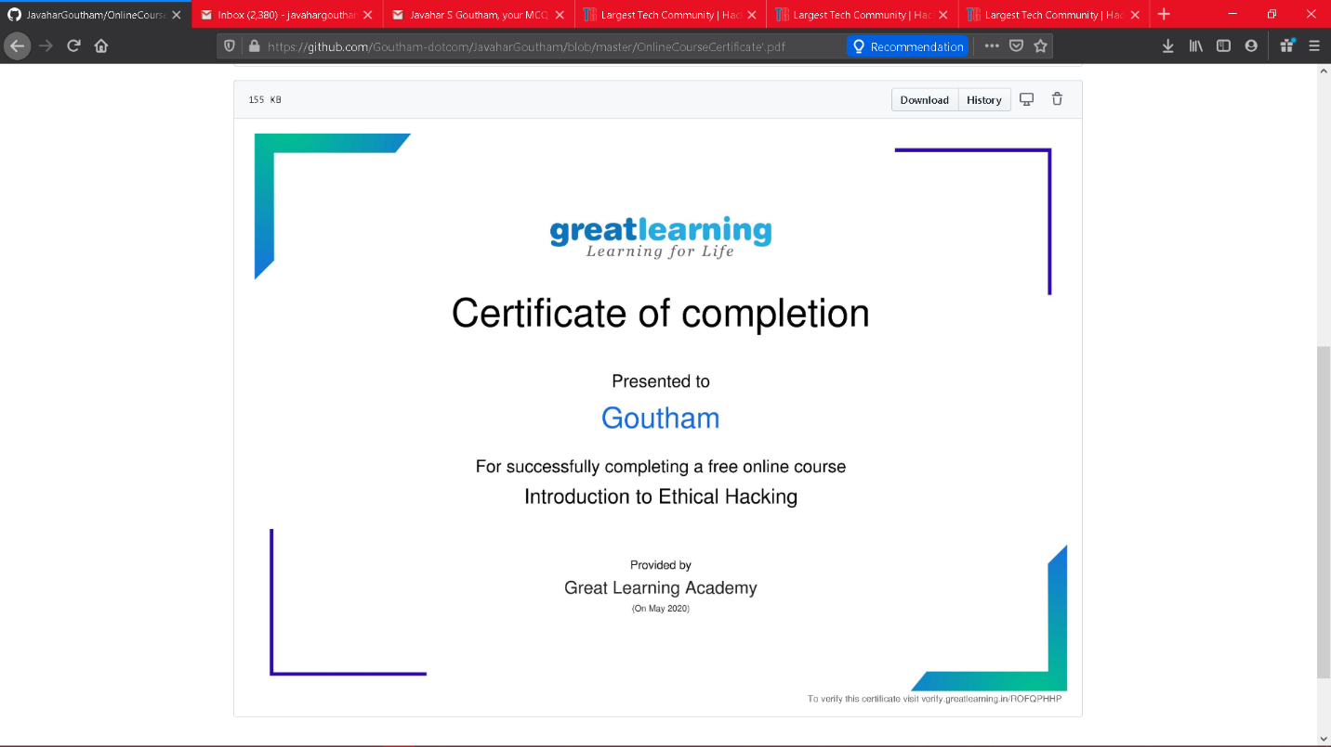

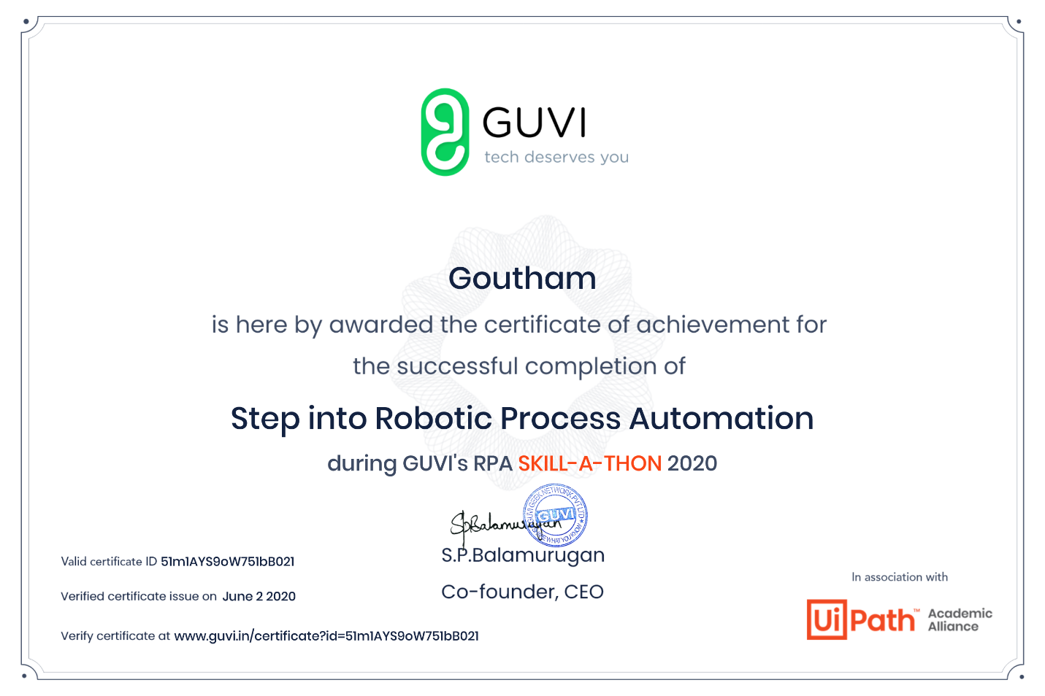

Coding Challenges Details: (Attach the snapshot and briefly write the report for the same)

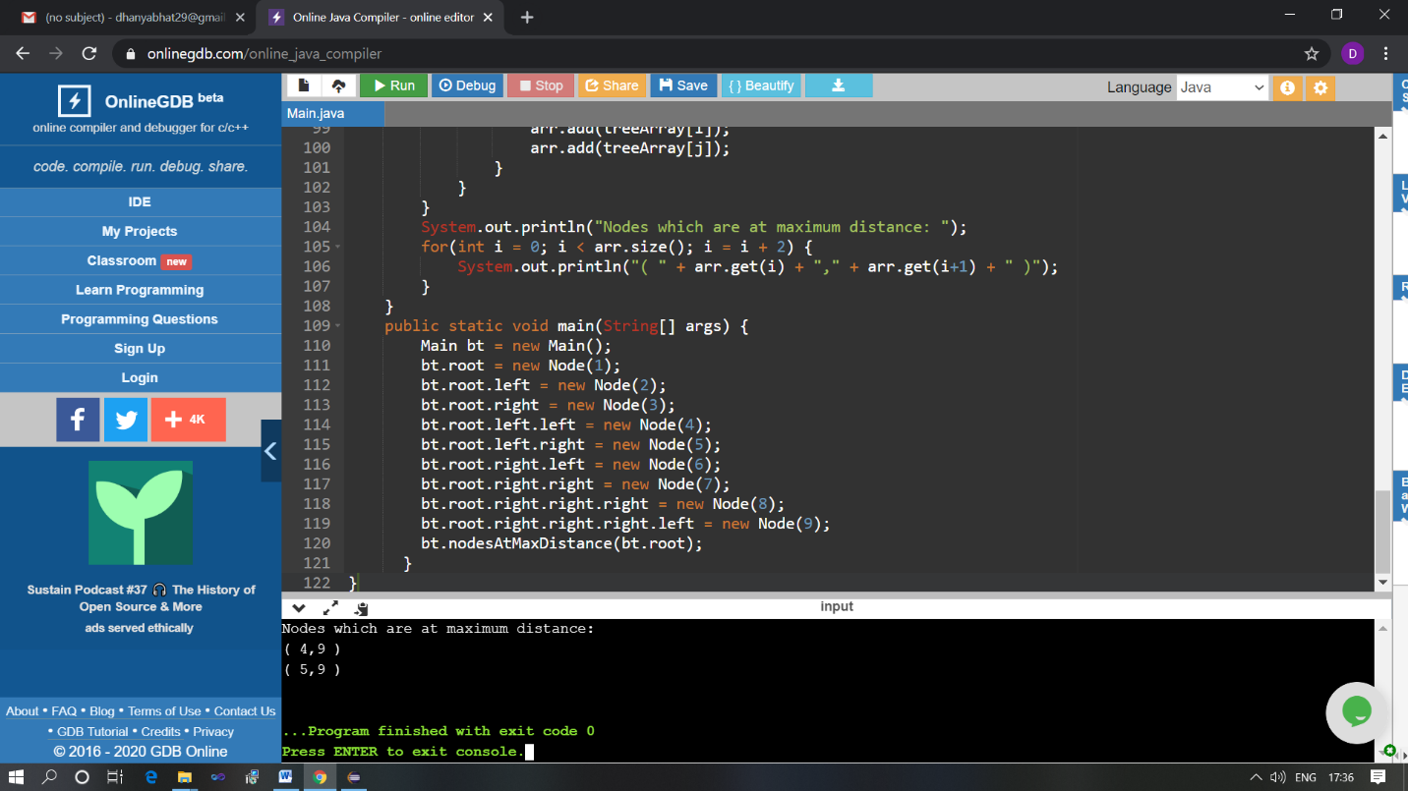

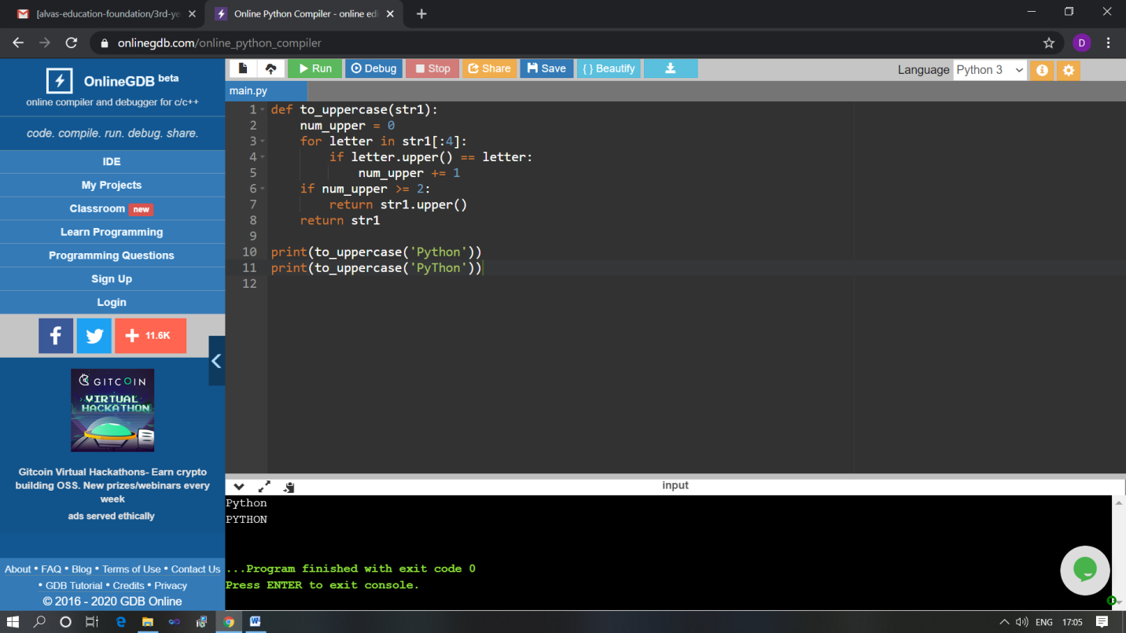

The above Programs were written and executed and the output of the same is displayed above. The code for those 2 programs have been uploaded to the github repository and the link to the same is provided on the form.